**Joseph Huaynate**

**CUNY ID: 7731  
 Class: CS-331  
 Project # 3**

Creation of EmailAccount Table

CREATE TABLE EmailAccount

(EmailAddress varchar(30) not NULL,

AcctFirstName varchar(15) not NULL,

AcctLastName varchar(15) not NULL,

Password varchar(30) not NULL,

DateAcctOpened date not NULL,

DateAcctClosed date,

PRIMARY KEY(EmailAddress)

);

ALTER TABLE EmailAccount

ADD PasswordExpire date not NULL;

Insert to EmailAccount Table

INSERT into EmailAccount(EmailAddress, AcctFirstName, AcctLastName, Password, DateAcctOpened, PasswordExpire)

VALUES('jahuay93@gmail.com', 'Joseph', 'Huaynate', 'Redbull987', '12-08-2007', '01-23-2017');

INSERT into EmailAccount(EmailAddress, AcctFirstName, AcctLastName, Password, DateAcctOpened, PasswordExpire)

VALUES('pridelands@gmail.com', 'Simba', 'Lyon', 'Hakunamatata90', '05-25-2010', '02-05-2017');

INSERT into EmailAccount(EmailAddress, AcctFirstName, AcctLastName, Password, DateAcctOpened, PasswordExpire)

VALUES('goldeneye@gmail.com', 'James', 'Bond', 'casionRoyal007', '08-30-2012', '02-15-2017');

INSERT into EmailAccount(EmailAddress, AcctFirstName, AcctLastName, Password, DateAcctOpened, PasswordExpire)

VALUES('rushhour888@gmail.com', 'Jackie', 'Chan', 'chinesezodiac888', '03-02-2011', '02-16-2017');

Creation of Messages Table

CREATE TABLE Messages

(MessageID number not NULL,

Subject varchar(50) not NULL,

CC varchar(30),

BCC varchar(30),

Body varchar(200),

SendDate date not NULL,

ReceivedDate date,

MessageSize varchar(10) not NULL,

Priority varchar(10) not NULL,

EmailAddress varchar(30) not NULL,

PRIMARY KEY(MessageID),

FOREIGN KEY(EmailAddress) references EmailAccount(EmailAddress));

ALTER TABLE Messages

ADD FolderLocation varchar(15) not NULL;

Insertion to Messages Table

INSERT into Messages(MessageID, Subject, Body, SendDate, ReceivedDate, MessageSize, Priority, EmailAddress, FolderID)

VALUES(1045160812, 'Project 3 DataBase', 'I wanted to clarify the instructions for Project 3. Thank You.' , '12-08-2016', '12-08-2016', 15, 'Medium', 'jahuay93@gmail.com', 9001 );

INSERT into Messages(MessageID, Subject, Body, SendDate, ReceivedDate, MessageSize, Priority, EmailAddress, FolderID)

VALUES(1724160912, 'WIN BIG PRIZES!!', 'You have been entered to compete in a raffle. Follow the link!' , '12-09-2016', '12-09-2016', 17 , 'Low', 'jahuay93@gmail.com', 9004 );

INSERT into Messages(MessageID, Subject, Body, SendDate, ReceivedDate, MessageSize, Priority, EmailAddress, FolderID)

VALUES(1351160212, 'Doctor Appointment', 'Hello Mrs.Morgan. Remember to make a follow up appointment!' , '12-02-2016', '12-02-2016', 12 , 'High', 'sally@yahoo.com', 9005 );

INSERT into Messages(MessageID, Subject, Body, SendDate, ReceivedDate, MessageSize, Priority, EmailAddress, FolderID)

VALUES(1542160212, 'Happy Birthday!', 'Have a wonderful day. I love you. Mom' , '08-02-2016', '08-02-2016', 15, 'Medium', 'jahuay93@gmail.com', 9000 );

INSERT into Messages(MessageID, Subject, Body, SendDate, ReceivedDate, MessageSize, Priority, EmailAddress, FolderID)

VALUES(1145160811, 'See You Soon!', 'I hope you are having a great time here. I will catch you later' , '11-08-2016', '11-08-2016', 16, 'Medium', 'jahuay93@gmail.com', 9000 );

INSERT into Messages(MessageID, Subject, Body, SendDate, ReceivedDate, MessageSize, Priority, EmailAddress, FolderID)

VALUES(1301161012, 'Remember me?', 'Hi love. Do you remember me? Reply if yes.' , '12-10-2016', '12-10-2016', 16, 'Medium', 'jahuay93@gmail.com', 9000 );

INSERT into Messages(MessageID, Subject, Body, SendDate, ReceivedDate, MessageSize, Priority, EmailAddress, FolderID)

VALUES(1821161112, 'Dentist Appt.', 'Hi Joseph. It is that time of year to check on your pearly whites. Call soon' , '12-11-2016', '12-11-2016', 14, 'High', 'jahuay93@gmail.com', 9000 );

INSERT into Messages(MessageID, Subject, Body, SendDate, ReceivedDate, MessageSize, Priority, EmailAddress, FolderID)

VALUES(2035160512, 'Click Link', 'Hi Customer! Please click on the link to view your report! www.spam.com' , '12-05-2016', '12-05-2016', 13, 'Low', 'jahuay93@gmail.com', 9000 );

INSERT into Messages(MessageID, Subject, Body, SendDate, ReceivedDate, MessageSize, Priority, EmailAddress, FolderID)

VALUES(1413161212, 'Bank Notice', 'Mrs. Morgan please go check your bank account. Thank you. ' , '12-12-2016', '12-12-2016', 15, 'High', 'sally@yahoo.com', 9005 );

INSERT into Messages(MessageID, Subject, Body, SendDate, ReceivedDate, MessageSize, Priority, EmailAddress, FolderID)

VALUES(1715161412, 'Call back!', 'Honey, please call back ASAP. Love you. - Peter ' , '12-14-2016', '12-14-2016', 16, 'Medium', 'sally@yahoo.com', 9005 );

INSERT into Messages(MessageID, Subject, Body, SendDate, ReceivedDate, MessageSize, Priority, EmailAddress, FolderID)

VALUES(0222161412, 'Hank Morgan', 'Mrs. Morgan the school would like to inform you that Hank has not attended class today. Call to make an Appt. ' , '11-13-2016', '11-13-2016', 15, 'High', 'sally@yahoo.com', 9005 );

INSERT into Messages(MessageID, Subject, Body, SendDate, ReceivedDate, MessageSize, Priority, EmailAddress, FolderID)

VALUES(1635160212, 'Lets Plan a Trip', 'Stacy! Message me ASAP. We are going to Vegas! ' , '12-02-2016', '12-02-2016', 15, 'Medium', 'sally@yahoo.com', 9006 );

INSERT into Messages(MessageID, Subject, Body, SendDate, ReceivedDate, MessageSize, Priority, EmailAddress, FolderID)

VALUES(1045160810, 'Visit Holland Today!', 'We would like to interest you in out Holiday travel special. Call us for more info. ' , '10-08-2016', '10-08-2016', 18, 'Medium', 'sally@yahoo.com', 9005 );

INSERT into Messages(MessageID, Subject, Body, SendDate, ReceivedDate, MessageSize, Priority, EmailAddress, FolderID)

VALUES(1501161312, 'Lets make this trip happen!', 'Sorry for the late response. Lets make this trip happen! Viva Las Vegas! Love Stacey ' , '12-13-2016', '12-13-2016', 15, 'Medium', 'sally@yahoo.com', 9008 );

INSERT into Messages(MessageID, Subject, Body, SendDate, ReceivedDate, MessageSize, Priority, EmailAddress, FolderID)

VALUES(1327161012, 'Is this Mary?', 'Sorry to bother but am I contacting Mary Fieldman?' , '12-10-2016', '12-10-2016', 15, 'Medium', 'sally@yahoo.com', 9005 );

INSERT into Messages(MessageID, Subject, Body, SendDate, ReceivedDate, MessageSize, Priority, EmailAddress, FolderID)

VALUES(1213161111, 'Wild Safari', 'Come to have an adventure. Contact our offices ASAP.' , '11-11-2016', '11-11-2016', 13, 'Medium', 'pridelands@gmail.com', 9010 );

INSERT into Messages(MessageID, Subject, Body, SendDate, ReceivedDate, MessageSize, Priority, EmailAddress, FolderID)

VALUES(1401161212, 'Super Sales!', 'As a dedicated customer we would love for you to come this weekend and enjoy our deals. So come down!' , '12-12-2016', '12-12-2016', 12, 'Medium', 'pridelands@gmail.com', 9010 );

INSERT into Messages(MessageID, Subject, Body, SendDate, ReceivedDate, MessageSize, Priority, EmailAddress, FolderID)

VALUES(1702160212, 'Listen to Me Simba!', 'Together we can rule the Pride Lands. Contact me for more info! - Uncle Scar' , '12-02-2016', '12-02-2016', 14, 'Medium', 'pridelands@gmail.com', 9012 );

INSERT into Messages(MessageID, Subject, Body, SendDate, ReceivedDate, MessageSize, Priority, EmailAddress, FolderID)

VALUES(1515160311, 'Hakuna Matata!', 'It is Pumpa. Dont forget that we love you and to come visit us soon!' , '11-03-2016', '11-03-2016', 10, 'Medium', 'pridelands@gmail.com', 9010 );

INSERT into Messages(MessageID, Subject, Body, SendDate, ReceivedDate, MessageSize, Priority, EmailAddress, FolderID)

VALUES(1601160410, 'Remember Your Purpose', 'Simba this is your father. Do not forgot why you want to lead the Pride Lands - Mufasa' , '10-04-2016', '10-04-2016', 11, 'Medium', 'pridelands@gmail.com', 9010 );

INSERT into Messages(MessageID, Subject, Body, SendDate, ReceivedDate, MessageSize, Priority, EmailAddress, FolderID)

VALUES(1101160311, 'Thank You Father', 'I have remembered my true purpose and reason as to why I want to continue being King. Love you father.' , '11-03-2016', '11-03-2016', 12, 'Medium', 'pridelands@gmail.com', 9011 );

INSERT into Messages(MessageID, Subject, Body, SendDate, ReceivedDate, MessageSize, Priority, EmailAddress, FolderID)

VALUES(1904160112, 'Visit Me Soon', 'This is Rafike. We need to discuss about the symbol that has been found.' , '12-01-2016', '12-01-2016', 11, 'Medium', 'pridelands@gmail.com', 9010 );

INSERT into Messages(MessageID, Subject, Body, SendDate, ReceivedDate, MessageSize, Priority, EmailAddress, FolderID)

VALUES(1055161009, 'New Mission', 'Bond please notify us ASAP so that you can go on your next mission. -M' , '09-10-2016', '09-10-2016', 12, 'High', 'goldeneye@gmail.com', 9015);

INSERT into Messages(MessageID, Subject, Body, SendDate, ReceivedDate, MessageSize, Priority, EmailAddress, FolderID)

VALUES(0945161612, 'Mission Completed', 'M I have completed the mission as ordered. - JB ' , '12-16-2016', '12-16-2016', 13, 'Medium', 'goldeneye@gmail.com', 9016);

INSERT into Messages(MessageID, Subject, Body, SendDate, ReceivedDate, MessageSize, Priority, EmailAddress, FolderID)

VALUES(1407161612, 'New Mission', 'Your new mission will take place in Spain. Be ready for more details.- M' , '12-16-2016', '12-16-2016', 12, 'Medium', 'goldeneye@gmail.com', 9015);

INSERT into Messages(MessageID, Subject, Body, SendDate, ReceivedDate, MessageSize, Priority, EmailAddress, FolderID)

VALUES(1503161112, 'Come To Vegas', 'Since you were our 100th visitor you can claim a prize. Click the link for more.' , '12-11-2016', '12-11-2016', 12, 'Medium', 'goldeneye@gmail.com', 9019);

INSERT into Messages(MessageID, Subject, Body, SendDate, ReceivedDate, MessageSize, Priority, EmailAddress, FolderID)

VALUES(1104161011, 'Reports Missing', 'Bond, it would be nice if you could send us reports from your last mission. -M' , '11-10-2016', '11-10-2016', 11, 'Medium', 'goldeneye@gmail.com', 9015);

INSERT into Messages(MessageID, Subject, Body, SendDate, ReceivedDate, MessageSize, Priority, EmailAddress, FolderID)

VALUES(1235161412, 'Your Lover', 'Bond, it is Maya. I love you. We have not seen each other since the last mission. Please call me.' , '12-14-2016', '12-14-2016', 10, 'Medium', 'goldeneye@gmail.com', 9015);

INSERT into Messages(MessageID, Subject, Body, SendDate, ReceivedDate, MessageSize, Priority, EmailAddress, FolderID)

VALUES(1613160410, 'I will get you!', 'Bond! I will avenge my fathers death. You will not escape next time! - V' , '10-04-2016', '10-04-2016', 10, 'Medium', 'goldeneye@gmail.com', 9015);

INSERT into Messages(MessageID, Subject, Body, SendDate, ReceivedDate, MessageSize, Priority, EmailAddress, FolderID)

VALUES(1805161012, 'Jackie!', 'Jackie we need to get started with RH 4. Call Me! - Chris Tucker' , '12-10-2016', '12-10-2016', 11, 'Medium', 'rushhour888@gmail.com', 9020);

INSERT into Messages(MessageID, Subject, Body, SendDate, ReceivedDate, MessageSize, Priority, EmailAddress, FolderID)

VALUES(1909160912, 'Father help', 'Dad I need your help with a project I am working on. - Jaycee' , '12-09-2016', '12-09-2016', 10, 'Medium', 'rushhour888@gmail.com', 9021);

INSERT into Messages(MessageID, Subject, Body, SendDate, ReceivedDate, MessageSize, Priority, EmailAddress, FolderID)

VALUES(2015160211, 'Jet Li!', 'Hey Jet Li we would love if you could work on our next movie!' , '11-02-2016', '11-02-2016', 11, 'Medium', 'rushhour888@gmail.com', 9022);

INSERT into Messages(MessageID, Subject, Body, SendDate, ReceivedDate, MessageSize, Priority, EmailAddress, FolderID)

VALUES(2045160512, 'Movie Star', 'Jackie I just want to congratulate you on your Oscar! ' , '12-05-2016', '12-05-2016', 12, 'Medium', 'rushhour888@gmail.com', 9020);

INSERT into Messages(MessageID, Subject, Body, SendDate, ReceivedDate, MessageSize, Priority, EmailAddress, FolderID)

VALUES(1130162911, 'Call Me', 'Jackie this is your wife. The woman you love. Call me please. ' , '11-29-2016', '11-29-2016', 11, 'Medium', 'rushhour888@gmail.com', 9020);

INSERT into Messages(MessageID, Subject, Body, SendDate, ReceivedDate, MessageSize, Priority, EmailAddress, FolderID)

VALUES(1202162711, 'Lets Make A Movie', 'Jackie this is Jet Li. Lets make an action movie. Message me. -JL ' , '11-27-2016', '11-27-2016', 11, 'Medium', 'rushhour888@gmail.com', 9020);

Creation of To_Message Table

CREATE TABLE To_Message

(ToID number not NULL,

Receiver varchar(20) not NULL,

MessageID number not NULL,

PRIMARY KEY(ToID),

FOREIGN KEY(MessageID) references Messages(MessageID));

Insertion to To_Message Table

INSERT INTO To_Message(TOID, Receiver, MessageID)

VALUES(8000, 'prof331@gmail.com', 1045160812)

INSERT INTO To_Message(TOID, Receiver, MessageID)

VALUES(8001, 'jahuay93@gmail.com', 1724160912)

INSERT INTO To_Message(TOID, Receiver, MessageID)

VALUES(8002, 'sally@yahoo.com', 1351160212)

INSERT INTO To_Message(TOID, Receiver, MessageID)

VALUES(8003, 'jahuay93@gmail.com', 1542160212)

INSERT INTO To_Message(TOID, Receiver, MessageID)

VALUES(8004, 'jahuay93@gmail.com', 1145160811)

INSERT INTO To_Message(TOID, Receiver, MessageID)

VALUES(8005, 'jahuay93@gmail.com', 1301161012)

INSERT INTO To_Message(TOID, Receiver, MessageID)

VALUES(8006, 'jahuay93@gmail.com', 1821161112)

INSERT INTO To_Message(TOID, Receiver, MessageID)

VALUES(8007, 'jahuay93@gmail.com', 2035160512)

INSERT INTO To_Message(TOID, Receiver, MessageID)

VALUES(8008, 'sally@yahoo.com', 1413161212)

INSERT INTO To_Message(TOID, Receiver, MessageID)

VALUES(8009, 'sally@yahoo.com', 1715161412)

INSERT INTO To_Message(TOID, Receiver, MessageID)

VALUES(8010, 'sally@yahoo.com', 0222161412)

INSERT INTO To_Message(TOID, Receiver, MessageID)

VALUES(8011, 'stacy@yahoo.com', 1635160212)

INSERT INTO To_Message(TOID, Receiver, MessageID)

VALUES(8012, 'sally@yahoo.com', 1045160810)

INSERT INTO To_Message(TOID, Receiver, MessageID)

VALUES(8013, 'sally@yahoo.com', 1501161312)

INSERT INTO To_Message(TOID, Receiver, MessageID)

VALUES(8014, 'sally@yahoo.com', 1327161012)

INSERT INTO To_Message(TOID, Receiver, MessageID)

VALUES(8015, 'pridelands@gmail.com', 1213161111)

INSERT INTO To_Message(TOID, Receiver, MessageID)

VALUES(8016, 'pridelands@gmail.com',1401161212)

INSERT INTO To_Message(TOID, Receiver, MessageID)

VALUES(8017, 'pridelands@gmail.com',1702160212)

INSERT INTO To_Message(TOID, Receiver, MessageID)

VALUES(8018, 'pridelands@gmail.com',1515160311)

INSERT INTO To_Message(TOID, Receiver, MessageID)

VALUES(8019, 'pridelands@gmail.com',1601160410)

INSERT INTO To_Message(TOID, Receiver, MessageID)

VALUES(8020, 'mufasa@gmail.com',1101160311)

INSERT INTO To_Message(TOID, Receiver, MessageID)

VALUES(8021, 'pridelands@gmail.com',1904160112)

INSERT INTO To_Message(TOID, Receiver, MessageID)

VALUES(8022, 'goldeneye@gmail.com',1055161009)

INSERT INTO To_Message(TOID, Receiver, MessageID)

VALUES(8023, 'topsecret@gmail.com',0945161612)

INSERT INTO To_Message(TOID, Receiver, MessageID)

VALUES(8024, 'goldeneye@gmail.com',1407161612)

INSERT INTO To_Message(TOID, Receiver, MessageID)

VALUES(8025, 'goldeneye@gmail.com',1503161112)

INSERT INTO To_Message(TOID, Receiver, MessageID)

VALUES(8026, 'goldeneye@gmail.com',1104161011)

INSERT INTO To_Message(TOID, Receiver, MessageID)

VALUES(8027, 'goldeneye@gmail.com',1235161412)

INSERT INTO To_Message(TOID, Receiver, MessageID)

VALUES(8028, 'goldeneye@gmail.com',1613160410)

INSERT INTO To_Message(TOID, Receiver, MessageID)

VALUES(8029, 'rushhour888@gmailcom',1805161012)

INSERT INTO To_Message(TOID, Receiver, MessageID)

VALUES(8030, 'rushhour888@gmailcom',1909160912)

INSERT INTO To_Message(TOID, Receiver, MessageID)

VALUES(8031, 'rushhour888@gmailcom',2015160211)

INSERT INTO To_Message(TOID, Receiver, MessageID)

VALUES(8032, 'rushhour888@gmailcom',2045160512)

INSERT INTO To_Message(TOID, Receiver, MessageID)

VALUES(8033, 'rushhour888@gmailcom',1130162911)

INSERT INTO To_Message(TOID, Receiver, MessageID)

VALUES(8034, 'rushhour888@gmailcom',1202162711)

Insertion to From_Messages Table

INSERT INTO From_Messages(FID, MessageID, FromEA)

VALUES(7000, 1045160812, 'jahuay93@gmail.com');

INSERT INTO From_Messages(FID, MessageID, FromEA)

VALUES(7001, 1724160912, 'garbagemail@gmail.com');

INSERT INTO From_Messages(FID, MessageID, FromEA)

VALUES(7002, 1351160212, 'doctor@gmail.com');

INSERT INTO From_Messages(FID, MessageID, FromEA)

VALUES(7003, 1542160212, 'raffel@gmail.com')

INSERT INTO From_Messages(FID, MessageID, FromEA)

VALUES(7004, 1145160811, 'family@gmail.com')

INSERT INTO From_Messages(FID, MessageID, FromEA)

VALUES(7005, 1301161012, 'lostlover@gmail.com')

INSERT INTO From_Messages(FID, MessageID, FromEA)

VALUES(7006, 1821161112, 'dentist10@gmail.com')

INSERT INTO From_Messages(FID, MessageID, FromEA)

VALUES(7007, 2035160512 , 'spammer@gmail.com')

INSERT INTO From_Messages(FID, MessageID, FromEA)

VALUES(7008, 1413161212 , 'banker@gmail.com')

INSERT INTO From_Messages(FID, MessageID, FromEA)

VALUES(7009, 1715161412 , 'banker@gmail.com')

INSERT INTO From_Messages(FID, MessageID, FromEA)

VALUES(7010, 0222161412, 'teacher001@gmail.com')

INSERT INTO From_Messages(FID, MessageID, FromEA)

VALUES(7011, 1635160212, 'sally@yahoo.com')

INSERT INTO From_Messages(FID, MessageID, FromEA)

VALUES(7012, 1045160810, 'airline@yahoo.com')

INSERT INTO From_Messages(FID, MessageID, FromEA)

VALUES(7013, 1501161312, 'stacey@yahoo.com')

INSERT INTO From_Messages(FID, MessageID, FromEA)

VALUES(7014, 1327161012, 'stranger@gmail.com')

INSERT INTO From_Messages(FID, MessageID, FromEA)

VALUES(7015, 1213161111, 'traveler@gmail.com')

INSERT INTO From_Messages(FID, MessageID, FromEA)

VALUES(7016, 1401161212, 'bigsales@gmail.com')

INSERT INTO From_Messages(FID, MessageID, FromEA)

VALUES(7017, 1702160212, 'scar@gmail.com')

INSERT INTO From_Messages(FID, MessageID, FromEA)

VALUES(7018, 1515160311, 'pumpa@gmail.com')

INSERT INTO From_Messages(FID, MessageID, FromEA)

VALUES(7019, 1601160410, 'mufasa@gmail.com')

INSERT INTO From_Messages(FID, MessageID, FromEA)

VALUES(7020, 1101160311, 'pridelands@gmail.com')

INSERT INTO From_Messages(FID, MessageID, FromEA)

VALUES(7021, 1904160112, 'rafike@gmail.com')

INSERT INTO From_Messages(FID, MessageID, FromEA)

VALUES(7022, 1055161009, 'topsecret@gmail.com')

INSERT INTO From_Messages(FID, MessageID, FromEA)

VALUES(7023, 0945161612, 'goldeneye@gmail.com')

INSERT INTO From_Messages(FID, MessageID, FromEA)

VALUES(7024, 1407161612, 'topsecret@gmail.com')

INSERT INTO From_Messages(FID, MessageID, FromEA)

VALUES(7025, 1503161112, 'vegasbaby@gmail.com')

INSERT INTO From_Messages(FID, MessageID, FromEA)

VALUES(7026, 1104161011, 'topsecret@gmail.com')

INSERT INTO From_Messages(FID, MessageID, FromEA)

VALUES(7027, 1235161412, 'mayaheart@gmail.com')

INSERT INTO From_Messages(FID, MessageID, FromEA)

VALUES(7028, 1613160410, 'villian@gmail.com')

INSERT INTO From_Messages(FID, MessageID, FromEA)

VALUES(7029, 1805161012, 'ctucker@gmail.com')

INSERT INTO From_Messages(FID, MessageID, FromEA)

VALUES(7030, 1909160912, 'jaycee@gmail.com')

INSERT INTO From_Messages(FID, MessageID, FromEA)

VALUES(7031, 2015160211, 'movies@gmail.com')

INSERT INTO From_Messages(FID, MessageID, FromEA)

VALUES(7032, 2045160512, 'agent@gmail.com')

INSERT INTO From_Messages(FID, MessageID, FromEA)

VALUES(7033, 1130162911, 'wife@gmail.com')

INSERT INTO From_Messages(FID, MessageID, FromEA)

VALUES(7034, 1202162711, 'jetli@gmail.com')

Creation of Folder Table

CREATE TABLE Folders

(FolderID number not NULL,

FolderName varchar(20) not NULL,

PRIMARY KEY(FolderID)

);

delete from Messages

WHERE MessageID = 2001;

ALTER TABLE Folders

ADD CONSTRAINT fk_EmailAddress FOREIGN KEY(FolderID) references Folders(FolderID);

Insertion to Folders Table

INSERT into Folders(FolderID, FolderName, EmailAddress)

VALUES(9000, 'Inbox', 'jahuay93@gmail.com');

INSERT into Folders(FolderID, FolderName, EmailAddress)

VALUES(9001, 'Sent', 'jahuay93@gmail.com');

INSERT into Folders(FolderID, FolderName, EmailAddress)

VALUES(9002, 'Junk', 'jahuay93@gmail.com');

INSERT into Folders(FolderID, FolderName, EmailAddress)

VALUES(9003, 'Friends', 'jahuay93@gmail.com');

INSERT into Folders(FolderID, FolderName, EmailAddress)

VALUES(9004, 'Spam', 'jahuay93@gmail.com');

INSERT into Folders(FolderID, FolderName, EmailAddress)

VALUES(9005, 'Inbox', 'sally@yahoo.com');

INSERT into Folders(FolderID, FolderName, EmailAddress)

VALUES(9006, 'Sent', 'sally@yahoo.com');

INSERT into Folders(FolderID, FolderName, EmailAddress)

VALUES(9007, 'Junk', 'sally@yahoo.com');

INSERT into Folders(FolderID, FolderName, EmailAddress)

VALUES(9008, 'Friends', 'sally@yahoo.com');

INSERT into Folders(FolderID, FolderName, EmailAddress)

VALUES(9009, 'Spam', 'sally@yahoo.com');

INSERT into Folders(FolderID, FolderName, EmailAddress)

VALUES(9010, 'Inbox', 'pridelands@gmail.com');

INSERT into Folders(FolderID, FolderName, EmailAddress)

VALUES(9011, 'Sent', 'pridelands@gmail.com');

INSERT into Folders(FolderID, FolderName, EmailAddress)

VALUES(9012, 'Junk', 'pridelands@gmail.com');

INSERT into Folders(FolderID, FolderName, EmailAddress)

VALUES(9013, 'Friends', 'pridelands@gmail.com');

INSERT into Folders(FolderID, FolderName, EmailAddress)

VALUES(9014, 'Spam', 'pridelands@gmail.com');

INSERT into Folders(FolderID, FolderName, EmailAddress)

VALUES(9015, 'Inbox', 'goldeneye@gmail.com');

INSERT into Folders(FolderID, FolderName, EmailAddress)

VALUES(9016, 'Sent', 'goldeneye@gmail.com');

INSERT into Folders(FolderID, FolderName, EmailAddress)

VALUES(9017, 'Junk', 'goldeneye@gmail.com');

INSERT into Folders(FolderID, FolderName, EmailAddress)

VALUES(9018, 'Friends', 'goldeneye@gmail.com');

INSERT into Folders(FolderID, FolderName, EmailAddress)

VALUES(9019, 'Spam', 'goldeneye@gmail.com');

INSERT into Folders(FolderID, FolderName, EmailAddress)

VALUES(9020, 'Inbox', 'rushhour888@gmail.com');

INSERT into Folders(FolderID, FolderName, EmailAddress)

VALUES(9021, 'Sent', 'rushhour888@gmail.com');

INSERT into Folders(FolderID, FolderName, EmailAddress)

VALUES(9022, 'Junk', 'rushhour888@gmail.com');

INSERT into Folders(FolderID, FolderName, EmailAddress)

VALUES(9023, 'Friends', 'rushhour888@gmail.com');

INSERT into Folders(FolderID, FolderName, EmailAddress)

VALUES(9024, 'Spam', 'rushhour888@gmail.com');

1. Identify the number of messages and total size by email accounts. Display four columns: email account, account owner name, number of messages and total size. Display the account with the greatest storage requirements first.

SELECT EmailAccount.EmailAddress "Email Address" , EmailAccount.AcctFirstName "First Name" , EmailAccount.AcctLastName "Last Name" ,COUNT(Messages.MessageID) "Number of Messages", SUM(Messages.MessageSize) "Message Size(KB)"

FROM EmailAccount, Messages

WHERE EmailAccount.EmailAddress = Messages.EmailAddress

GROUP BY EmailAccount.EmailAddress, EmailAccount.AcctFirstName, EmailAccount.AcctLastName

ORDER BY 5 DESC;

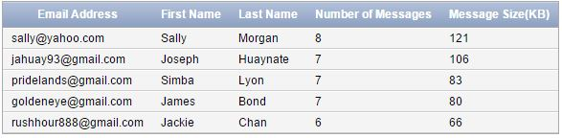

1. Send a new message to sally@yahoo.com. Identify the SQL operations to create

and send the message. In addition, Display the new message in the SENT folder

and the new message in Sally’s INBOX folder.

INSERT into Messages(MessageID, Subject, Body, SendDate, ReceivedDate, MessageSize, Priority, EmailAddress, FolderID)

VALUES(1111160212, 'Dear Hubby', 'Peter I want to say that I love you. - Your wife ' , '12-02-2016', '12-02-2016', 11, 'Medium', 'sally@yahoo.com', 9006);

SELECT Messages.EmailAddress "Email Address", Folders.FolderName "Folder Name", Messages.MessageID "Message No.", Messages.Subject "Subject", Messages.Body "Body"

FROM Messages, Folders

WHERE Messages.EmailAddress = Folders.EmailAddress

AND Messages.FolderID = Folders.FolderID

AND Folders.FolderID = 9006

AND MessageID = 1111160212;





1. Move a message from the JUNK to the FRIENDS folder for the account

*Rushhour888@gmail.com*. Identify the SQL operations required to implement. In

addition, display the JUNK and FRIENDS folder before and after the operation.

SELECT Messages.EmailAddress "Email Address", Folders.FolderName "Folder Name", Messages.MessageID "Message No.", Messages.Subject "Subject", Messages.Body "Body", Messages.SendDate "Send Date", Messages.ReceivedDate "Reeceived Date"

FROM Messages, Folders

WHERE Messages.EmailAddress = Folders.EmailAddress

AND Messages.FolderID = Folders.FolderID

AND Folders.FolderID = 9022

AND MessageID = 2015160211;



UPDATE Messages

SET FolderID = 9023

WHERE EmailAddress = 'rushhour888@gmail.com'

AND MessageID = 2015160211;

SELECT Messages.EmailAddress "Email Address", Folders.FolderName "Folder Name", Messages.MessageID "Message No.", Messages.Subject "Subject", Messages.Body "Body", Messages.SendDate "Send Date", Messages.ReceivedDate "Reeceived Date"

FROM Messages, Folders

WHERE Messages.EmailAddress = Folders.EmailAddress

AND Messages.FolderID = Folders.FolderID

AND Folders.FolderID = 9023

AND MessageID = 2015160211;



1. Create a SQL view to display all messages in the INBOX folder for

sally@yahoo.com. Display the columns Received Date, FROM, TO, Subject.

Display the most recent message first.

CREATE VIEW EmailAddressV1

AS SELECT Messages.ReceivedDate "Received Date" , From_Messages.FromEA "From" , To_Message.Receiver "To", Messages.Subject

FROM Messages, From_Messages, To_Message

WHERE Messages.MessageID = From_Messages.MessageID

AND Messages.MessageID = To_Message.MessageID

AND Messages.EmailAddress = 'sally@yahoo.com'

AND Messages.FolderID = 9005;

SELECT * FROM EmailAddressV2;

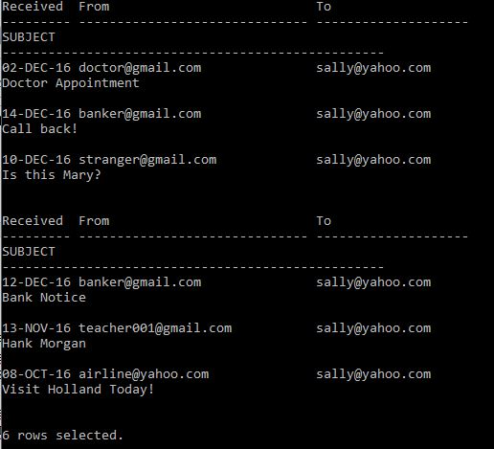

1. Identify all messages with the term **love** in the subject or body. Display the

columns Received Date, FROM, TO, Subject. Display the most recent message

first.

SELECT Messages.ReceivedDate "Received Date" , From_Messages.FromEA "From" , To_Message.Receiver "To", Messages.Subject

FROM Messages, From_Messages, To_Message

WHERE Messages.MessageID = From_Messages.MessageID

AND Messages.MessageID = To_Message.MessageID

AND Messages.Subject LIKE '%ov%'

and Messages.Body LIKE '%ov%';

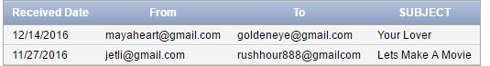

1. Delete one message. Discuss your approach to delete messages and identify the

SQL operations required to implement. Display the folder before and after the

deletion.

First Select the message you want to delete.

SELECT * FROM Messages

WHERE EmailAddress = 'sally@yahoo.com'

AND MessageID = 1351160212;



Since the Message is also associated with To and From, we must first delete those fields.

DELETE FROM To_Message

WHERE MessageID = 1351160212;

DELETE FROM From_Messages

WHERE MessageID = 1351160212;

Now we can delete from the Messages Table:

DELETE FROM Messages

WHERE MessageID = 1351160212;

Now I will show you the Folder

SELECT Messages.EmailAddress "Email Address", Folders.FolderName "Folder Name", Messages.MessageID "Message No.", Messages.Subject "Subject", Messages.Body "Body"

FROM Messages, Folders

WHERE Messages.EmailAddress = Folders.EmailAddress

AND Messages.FolderID = Folders.FolderID

AND Folders.FolderID = 9005;

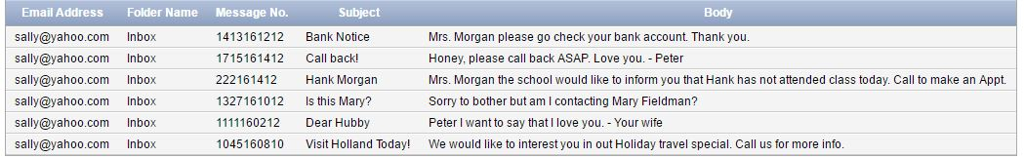

As you can see the message with MessageID 1351160212 no longer is the INBOX Folder.

1. Identify and move spam messages to the JUNK folder. Identify the SQL

operations required to implement.

SELECT Messages.EmailAddress "Email Address", Folders.FolderName "Folder Name", Messages.MessageID "Message No.", Messages.Subject "Subject", Messages.Body "Body"

FROM Messages, Folders

WHERE Messages.EmailAddress = Folders.EmailAddress

AND Messages.FolderID = Folders.FolderID

AND Folders.FolderName = 'Spam';



UPDATE Messages

SET FolderID = 9002

WHERE EmailAddress = 'jahuay93@gmail.com'

AND MessageID = 1724160912;

UPDATE Messages

SET FolderID = 9017

WHERE EmailAddress = 'goldeneye@gmail.com'

AND MessageID = 1503161112;

SELECT Messages.EmailAddress "Email Address", Folders.FolderName "Folder Name", Messages.MessageID "Message No.", Messages.Subject "Subject", Messages.Body "Body"

FROM Messages, Folders

WHERE Messages.EmailAddress = Folders.EmailAddress

AND Messages.FolderID = Folders.FolderID

AND Folders.FolderName = 'Junk';

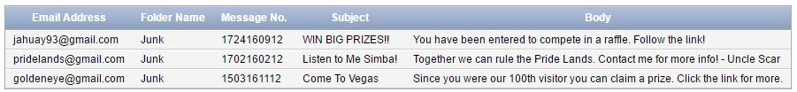

1. Identify accounts that have not received new messages today. Display the email

address.

SELECT Messages.EmailAddress "Email Address"

FROM Messages

WHERE ReceivedDate < '12-16-2016';

1. In one SQL window, move message 1 to a new folder. Don’t commit. In another

SQL window, move message 1 to different folder. Don’t commit. Explain your

results. Resolve the problem. Disable the auto commit flag at the top of the

window before performing this operation.

What happens is that since the first session has updated but not committed, you are left with an uncommitted value in session 1. If you try to modify the value in another session, the update will wait until you have a committed value in session 1.

1. In one SQL window, delete all messages for one account. Don’t commit. In

another SQL window, move all messages for the same account to the FRIENDS

folder. Don’t commit. Explain your results. Resolve the problem. Create a

backup of your table before implementing. To create a backup table, enter

CREATE TABLE <NEWTABLE> AS SELECT * FROM

<ORIGINALTABLE>; COMMIT; Then you can rename a table using the

RENAME TABLE commit. Disable the auto commit flag at the top of the

window before performing this operation.

The same seems to happen in this situation as it did in question 9. Since there was no commit in Session 1, you have deleted but only in the local session. Without the commit you have locked the row. So in session 2, you will be waiting until there are committed values. Well to resolve the problem one would just have to write commit on Session 1, assuming you wanted to delete the messages in the first place. If not then a rollback would be needed and then you can execute the second command in session 2.

1. In one SQL window, change the password for account 1. Don’t commit. In

another SQL window, change the last name of the owner of account 1. Don’t

commit. Quit both Oracle sessions. Login to Oracle and display all information.

Explain your results. Disable the auto commit flag at the top of the windows

before performing this operation.

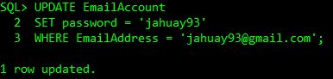

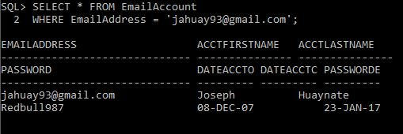

There was no change because once you quit both Oracle sessions without committing the locks were reset and the values were no longer pending change. Thus the original values are shown when you reenter and display the information.

1. desc EmailAccount;

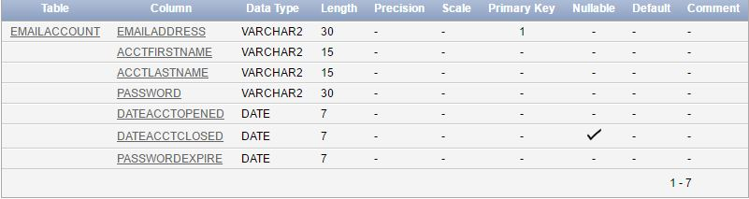

Desc Messages;

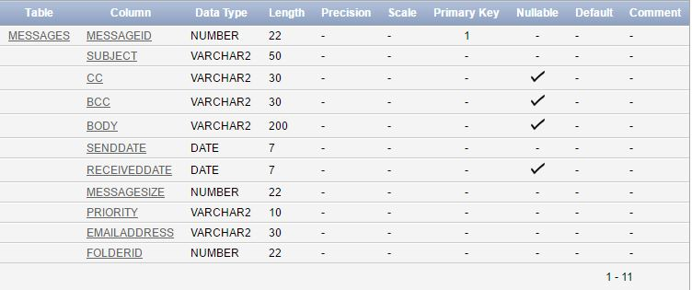

Desc To_Message;

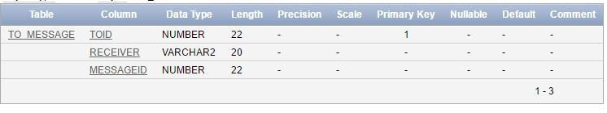

Desc From_Messages;

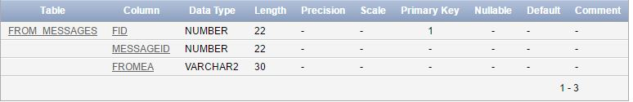

Desc Folders;

